Exp. 1 Design a LED Flasher

Circuit Diagram

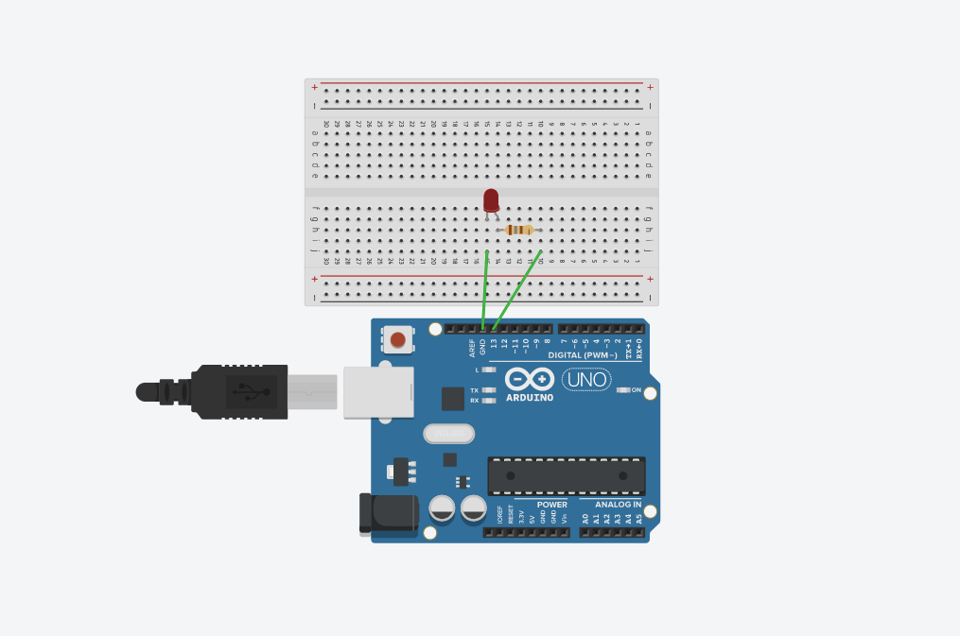

Theory

Concept used:

1. Ohm’s law

Ohm’s law states that the voltage across two points is directly proportional to the current flowing through the conductor and is inversely proportional to the resistance.

2. Breadboard

The holes in the rows at the top and bottom of the breadboard are connected in series and the ones in the columns are connected with each other.

1. Arduino

The Arduino processes the code and converts it into electrical signal.

Learning and observations

Learning

* I learned how connections are made using breadboard.
* The digital pins (from 0-13) of the Arduino board can be used as both input or output pins.
* The anode of the LED is connected to GND on the Arduino which acts as ground.

Observations

* The LED blinks continuously when the code is uploaded to the Arduino board.

Problems and troubleshooting

* The LED bulb was burned out. Old LED had to be replaced with a new one.
* The connections were not tight. I had to make the connections tight.
* The circuit was not closed due to wrong connections of wires. I had to connect the wires properly.
* The code was not providing the required output. I had to make changes in the code.

Precautions

* The connections should be tight and clean
* The LED should be appropriately connected, the cathode with the pin of Arduino and the anode with the ground.
* The correct port and board should be selected.
* The current flowing through the LED should not exceed the maximum limit. Use appropriate resistance.

Learning outcomes

* I have learned how to make circuits using Arduino and breadboard.
* I have learned the basic code to make the LED blink which will act as a base for the more complex blinking patterns.